2024 Annual Assessor School

July 29th – August 2nd
Brookings, SD

Hotel Accommodations

A block of rooms has been reserved at the Comfort Suites University, 929 25th Ave. Brookings, SD. To reserve a room(s), contact general manager, Lori:

1-605-520-9207 or lori@den-wil.com

Room rates will be $75. The block is under “SDAAO”. You can work with Lori to set up direct billing and tax-exempt credit card booking if needed.

Registration
Complete the form on the last page and return along with tuition payment to the SDAAO Treasurer. Do not return the registration form without the tuition. Please keep a copy of your registration form for your records.

Tuition for SDAAO members and SD county personnel:
$500

Course 1 – Rural Property Rights & Topics Related to Appraisal
See attached tentative schedule.

Instructor: Ryan McKnight, Brian Gatzke,
Dr. Ujah Nacasius, and other speakers
Prerequisite: none
Required Texts: None
Cost: $500

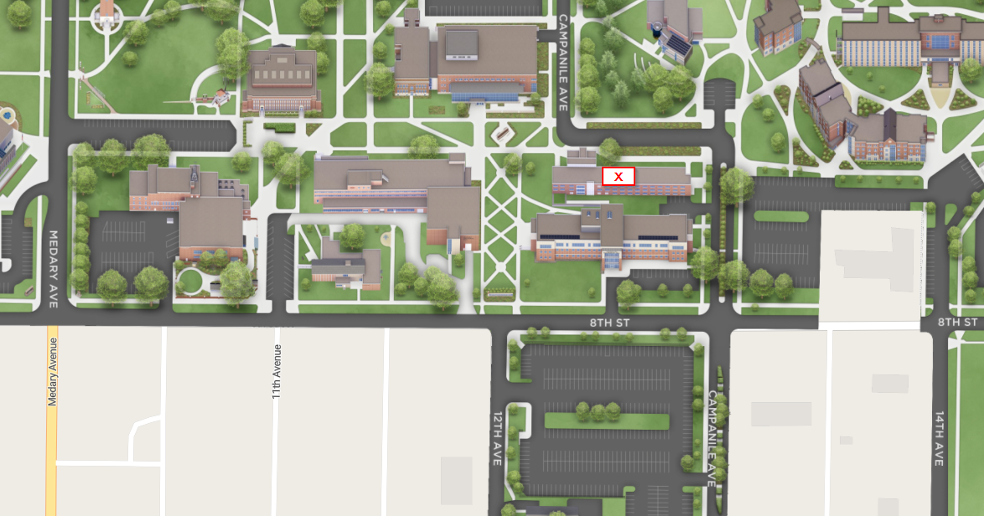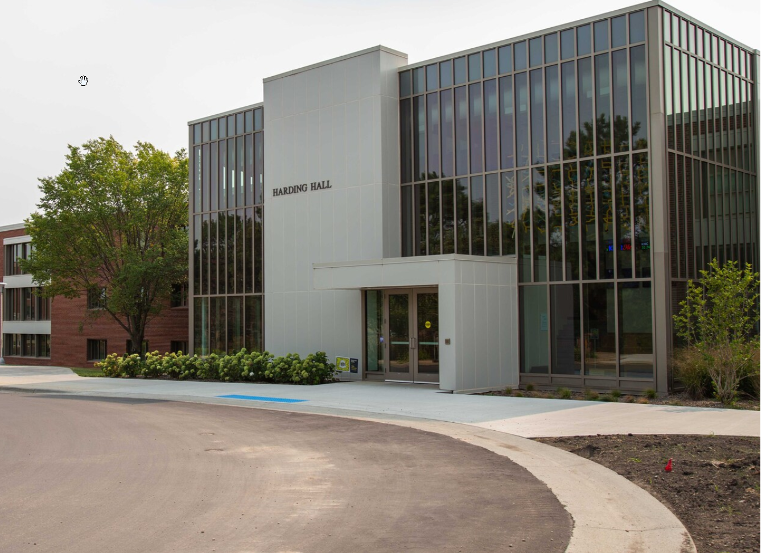

Class Location: SDSU Campus
SDSU Campus
Harding Hall
Room 0025
Brookings, SD

Class Schedule: Monday through Thursday
All classes will begin at 8:00 am and adjourn at 4:00 pm.
All classes will test on Friday morning starting at 8:00 AM.
There are breaks in the morning and afternoon where coffee and refreshments will be provided.

Meals
All school participants are responsible for their own meals.

School Rules
Attendance
Students are required to attend all sessions of the course they are taking. Roll will be taken in the classes and those students absent from any session will have points deducted from their test score. If the student has been absent from more than one session, credit for the school may be withheld and the student’s supervisor may be notified.

Cell Phones
Please observe these common cell phone courtesies:
- Have the phone turned off or to silent in the classroom.
- If you must take or place a call, do not do so in the classroom or in the hallway directly outside of the classrooms
- Calculators on phones are not allowed during tests

Required Texts and Class Materials
All course material will be provided unless otherwise noted. Students are responsible for bringing the “required texts” listed for their respective course. If you need assistance in acquiring a text, contact the Department of Revenue.

In addition to the required texts, students should bring
- a calculator the student is familiar with
  - cell phone calculators are not allowed during tests
- pencils, note pad, and other items normally used in class

Course Tests
No early tests will be allowed. Make up tests will be allowed only in accordance with the test policies laid out in administrative rule. Consult ARSD 64:02:03:19 for complete explanation of rules on testing and re-testing courses at the annual schools.

2024 Annual Assessor School

Make all checks payable to SDAAO

Tuition is $500

COUNTY _______________________

Contact email

_________________________________
Mail registration and payment to:
SDAAO
C/O Rhea Crane
1300 Sherman St, Ste 222
Sturgis, SD 57785

 | STUDENT NAME (print or type) | Course | Amount  submitting
1.
2.
3.
4.
5.
6.
7.
8.
 |  | TOTAL AMOUNT DUE: | $

